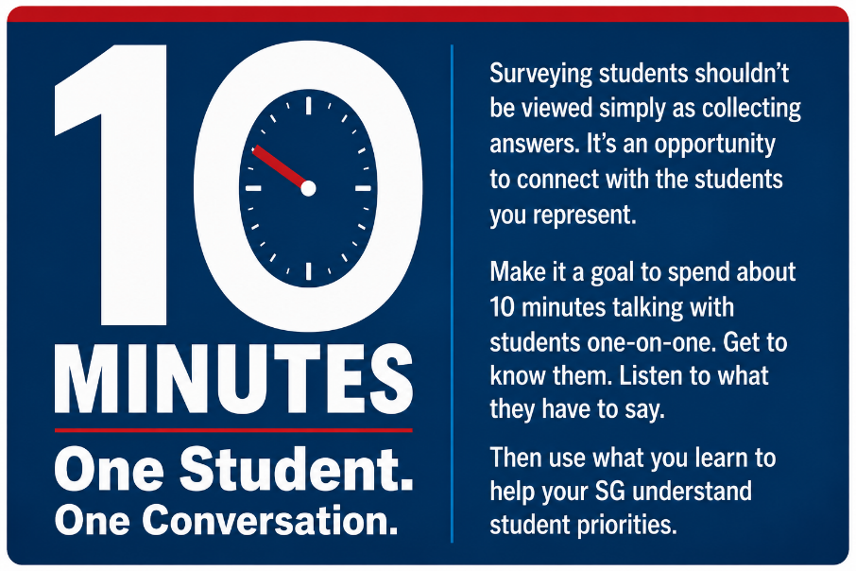
10-Minute Student
Conversation Guide

Connect With Your Students
How well does your Student Government really know the students it represents?
Most SG leaders hear from students in a few familiar ways. Someone sends an email. A student comes to a meeting. A friend mentions a problem. A few students become regular voices in SG discussions.
Those conversations matter, but they’re only part of the picture.
Go talk with your students.
Make it a goal to spend about 10 minutes talking with a student one-on-one. Find out what their experience is like. Ask what’s going well and what could be better. Get to know someone you might not otherwise have a reason to meet.
It doesn’t have to be formal. In fact, it shouldn’t be.
Have a conversation!

Go Where Students Are
Don’t wait for students to come to your SG office or attend a meeting.
Look for them where they already spend their time:
- Student centers
- Dining areas
- Campus events
- Residence halls
- Libraries
- Outdoor areas
- Anywhere students gather
Talk with students you don’t already know. Make an effort to hear from people outside your usual circle.

Start With a Simple Introduction
You can make this much easier by simply explaining what you’re doing.
For example:
“Hi, I’m [name]. I’m involved with Student Government, and we’re trying to do a better job of talking with students and finding out what’s important to them. Do you have about 10 minutes to talk?”
Then see where the conversation goes.

Listen More Than You Talk
You don’t need to work your way through a list of questions.
Ask something. Listen to the answer. If the student brings up something interesting, stay with it.
A simple “Tell me more about that” can lead to a much better conversation than moving immediately to another question.
You might also ask:
“Why is that important to you?”
“How does that affect you?”
“Have you talked with anyone about it?”
The best conversations usually don’t feel like interviews.

Don’t Try to Fix Everything
You’ll hear complaints. You’ll hear ideas. Some will be realistic. Others won’t be.
You don’t have to promise anything.
You don’t have to defend what SG is already doing.
You don’t even have to have an answer.
Sometimes the most useful thing you can do is listen carefully and thank the student for telling you about their experience.

Keep Talking With Different Students
One conversation can teach you something. It doesn’t tell you what every student thinks.
That’s why this should become a regular part of your SG’s work.
Talk with different students. Pay attention to what you hear. If the same concern keeps coming up, you may have found something worth exploring further.
That’s where personal conversations can become useful in setting SG priorities.

Keep the Purpose in Mind
The purpose isn’t to collect as many answers as possible.
Get to know your students.
Find out what’s important to them. Listen to what they have to say. Then use what you learn, along with other information you gather, to make better decisions about what your Student Government should work on.

